**Local School Performance Report**

Table of Contents

Introduction 2

Local Government Area Summary 2

School Summary 2

Top Performing Schools (By % Overall Passing) 3

Bottom Performing Schools (By % Overall Passing) 3

Maths Scores by Year 3

Reading Score by Year 3

Scores by School Spending 4

Scores by School Size 4

Scores by School Type 4

Summaries: 5

Conclusion: 5

## Introduction

The purpose of this project is to analyse the area wide standardized test results to help the school board and mayor to make strategic decisions regarding future school budgets and priorities.

(Student’s maths and reading scores and some other students’ data is provided in students_complete.csv and local schools information with their type, size, and budget is provided in schools_complete.csv)

## Local Government Area Summary



## School Summary

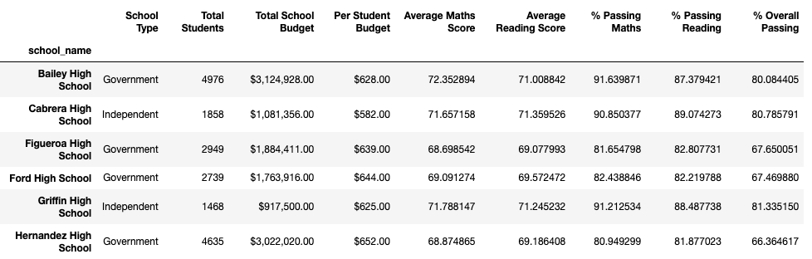

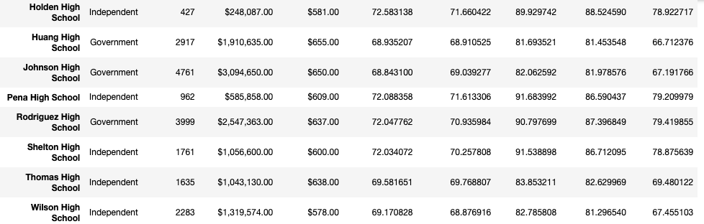



## Top Performing Schools (By % Overall Passing)

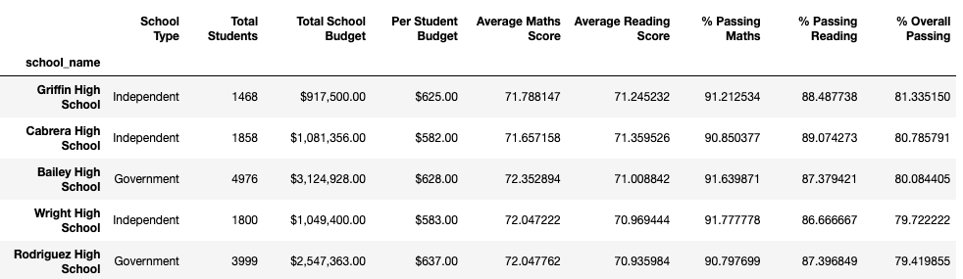

## Bottom Performing Schools (By % Overall Passing)

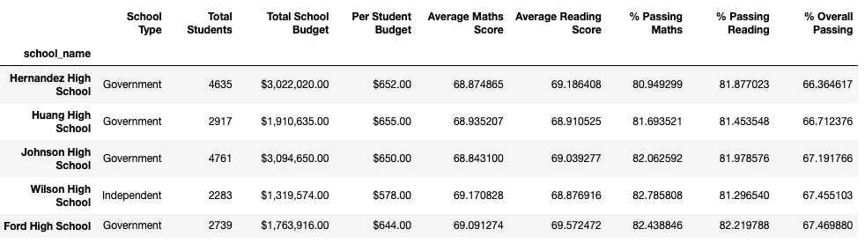

## Maths Scores by Year

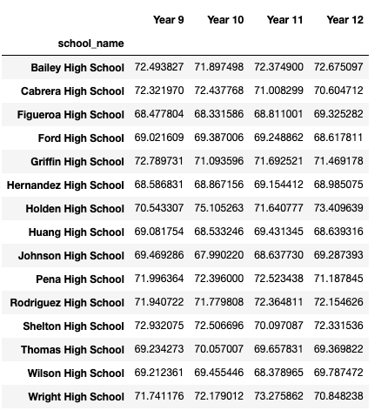

## 

## Reading Score by Year

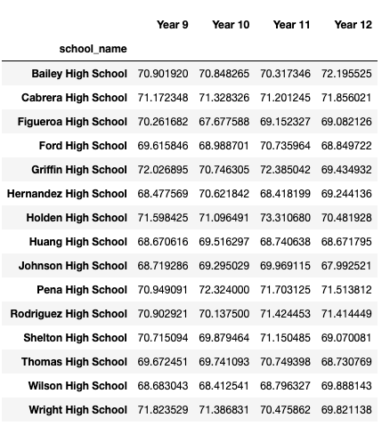

## Scores by School Spending

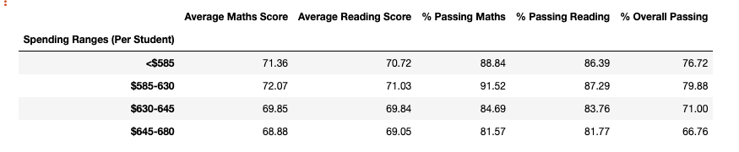

## Scores by School Size

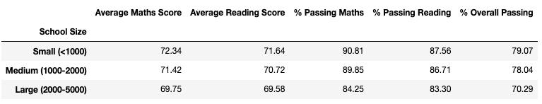

## Scores by School Type

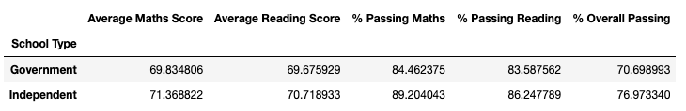

## Summaries:

Local Government Area Summary:

• The Local Government Area Summary provides a comprehensive overview of key statistics. It's worth noting that the area consists of a total of 15 schools, with 7 government schools and 8 independent schools.

Top-Performing Schools:

• Among the top 5 schools with the highest overall passing rates, 3 are independent schools, and 2 are government schools. Griffin High School claims the top spot with an exceptional overall passing rate of 81.3%.

Bottom-Performing Schools:

• In contrast, among the 5 schools with the lowest overall passing rates, all 4 are government schools. Hernandez High School ranks at the bottom with an overall passing rate of 66.36%.

Spending Range Impact:

• The analysis reveals that schools with a budget per student in the $585-$630 spending range exhibit the highest overall passing rate at 79.88%. However, as the budget per student increases, there is a decline in overall passing rates.

Effect of School Size:

• When examining school performance based on size, smaller schools with fewer than 1000 students (<1000) achieve the highest overall passing rate at 79.07%. Conversely, larger schools, with a higher student population, experience a decrease in overall passing rates.

School Type Comparison:

• The analysis indicates that independent schools outperform government schools, with an overall passing rate of 76.9% compared to 70.7% for government schools.

## Conclusion:

School Type Impact on Performance:

The analysis reveals a significant difference in performance between independent and government schools. Independent schools, with an overall passing rate of 76.9%, outperform government schools, which have an overall passing rate of 70.7%. This suggests that, on average, students in independent schools are more likely to pass both math and reading standardized tests compared to their counterparts in government schools.

Impact of School Size on Performance:

Smaller schools, often classified as "small size" with fewer students, tend to have a more favourable environment for student success, as evidenced by their higher overall passing rates. This suggests that smaller schools may be better equipped to provide personalized attention, support, and engagement for students, contributing to improved standardized test outcomes.